
LESSON NOTE | DETAILED EXPLANATORY NOTES
BIOENERGY
BIOGAS PRODUCTION
GRADE 12 - BIOLOGY
■ ■ ■

What is Biogas?
Biogas is a fuel gas made when bacteria break down wet organic waste without oxygen - a process called anaerobic digestion. The gas produced is mostly methane (CH₄), with carbon dioxide and small amounts of other gases. Because methane burns easily, biogas can be used for cooking, lighting and generating electricity, while the leftover slurry makes an excellent fertiliser.
Biogas is a form of bioenergy: the energy in it came originally from the Sun, captured by plants during photosynthesis and passed into the animal dung and food waste that feed the digester. Because these wastes are produced all the time, biogas is a renewable and roughly carbon-neutral source of energy. This lesson looks at what biogas is, how it is made, the design of a digester, its uses, the factors that affect production, and its potential in Papua New Guinea.
Why Biogas Matters
- It turns waste - dung, food scraps and sewage - into useful fuel and fertiliser.
- It is renewable and roughly carbon-neutral.
- It gives rural households a clean cooking fuel, reducing firewood use and indoor smoke.
- It improves sanitation by safely treating animal and human waste.
Biogas Production
Key Learning Outcomes
By the end of this lesson, students should be able to:
- Define biogas and state its main components.
- Explain anaerobic digestion and name the four stages.
- Describe the structure and working of a simple biogas digester.
- List common feedstocks and the uses of biogas and slurry.
- Discuss the factors affecting biogas production, and its advantages, limitations and use in Papua New Guinea.
What is Anaerobic Digestion?
Anaerobic digestion is the breakdown of organic material by microorganisms (bacteria) in the absence of oxygen (anaerobic = 'without air'). Inside a sealed tank, several groups of bacteria work in turn on the waste, releasing biogas as a by-product. The same process happens naturally in swamps, rice paddies and the stomachs of cattle - a biogas digester simply captures it in a controlled way. The main feedstocks (raw materials) are:
- Animal dung - from cattle, pigs and poultry (the most common feedstock).
- Food and kitchen waste - peelings, scraps and spoiled food.
- Human sewage - from toilets connected to the digester.
- Crop residues - leaves, stalks and other soft plant matter.
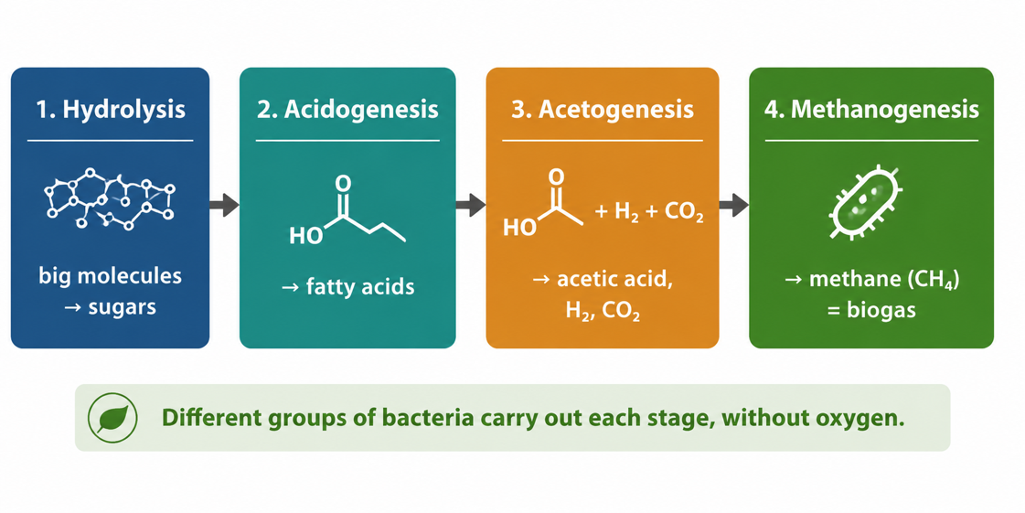
Figure 1: Anaerobic digestion happens in four stages, ending in methane (biogas).
Terminologies and Concepts
Useful terms for this topic:
- Biogas: a fuel gas (mainly methane) made by the anaerobic digestion of organic waste.
- Anaerobic: without oxygen. Aerobic means with oxygen.
- Anaerobic digestion: breakdown of organic matter by bacteria without oxygen.
- Methane (CH₄): the flammable gas that makes biogas a useful fuel.
- Feedstock: the organic material fed into the digester.
- Digester: the sealed tank in which anaerobic digestion takes place.
- Slurry: the liquid residue left after digestion, used as fertiliser.
- Renewable/carbon-neutral: replaceable as fast as used; releasing only recently-absorbed CO₂.
The Four Stages of Digestion
Different groups of bacteria carry out four stages, one after another:
- Hydrolysis - bacteria break large molecules (carbohydrates, fats, proteins) into small soluble ones such as sugars, fatty acids and amino acids.
- Acidogenesis - these small molecules are fermented into organic acids (such as fatty acids), plus some hydrogen and carbon dioxide.
- Acetogenesis - the acids are converted into acetic acid, hydrogen and carbon dioxide.
- Methanogenesis - special methanogenic bacteria turn these products into methane (CH₄) and carbon dioxide - the biogas itself.
The methane is the useful, flammable part of the biogas; the mixture is typically about 50–70% methane and 30–40% carbon dioxide.
The Biogas Digester
A digester is the sealed, airtight tank where anaerobic digestion happens. A simple household digester has a few key parts. Waste and water are mixed and poured into the inlet, where they enter the digestion chamber. Bacteria break down the waste, and the biogas that forms rises and collects in a gas dome (or holder) at the top. The gas is drawn off through a gas outlet pipe to a stove or lamp, while the digested slurry overflows through the outlet to be collected as fertiliser.
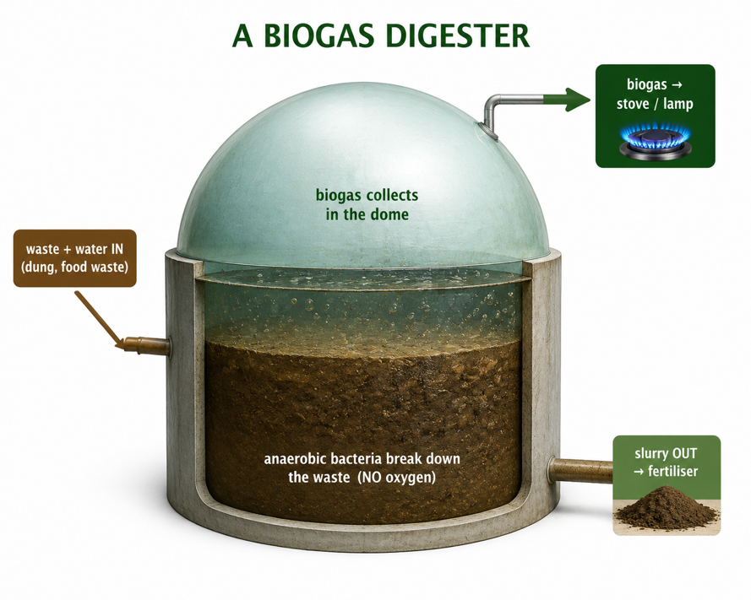
Figure 2: A simple biogas digester - waste in, biogas collected from the dome, slurry out as fertiliser.

Main Parts of a Digester
- Inlet: where the waste-and-water mixture is fed in.
- Digestion chamber: the airtight tank where bacteria break down the waste.
- Gas dome / holder: collects and stores the biogas as it forms.
- Gas outlet pipe: carries the biogas to the stove, lamp or generator.
- Slurry outlet: where the digested residue leaves the tank to be used as fertiliser.
Uses of Biogas and Slurry
Biogas is a versatile fuel, and nothing is wasted - even the residue is valuable:
- Cooking - biogas burns with a clean flame, replacing firewood and reducing smoke.
- Lighting - it can be burned in gas lamps.
- Electricity - it can run a generator or engine to produce power.
- Fertiliser - the leftover slurry is rich in nutrients and improves crop growth.
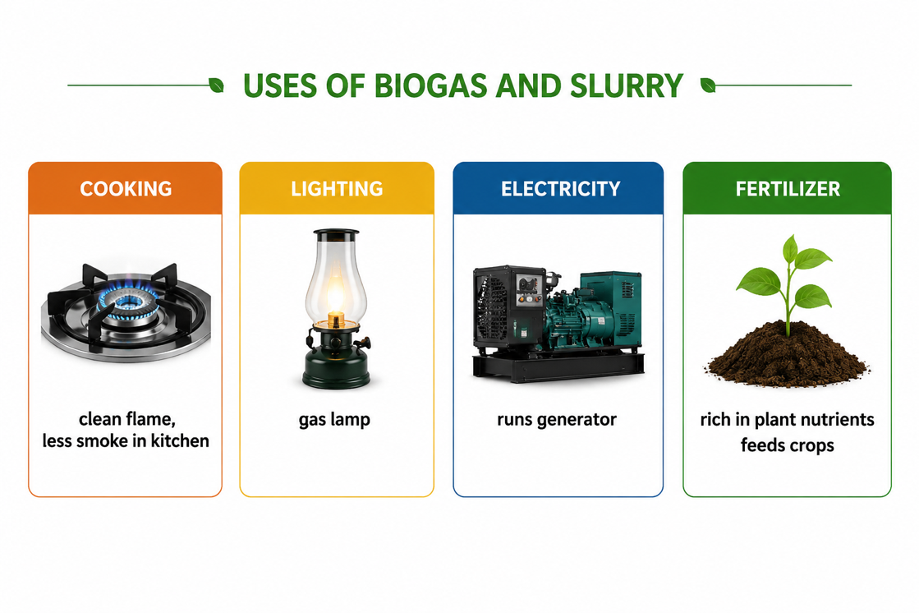
Figure 3: Biogas can be used for cooking, lighting and electricity, and the slurry makes fertiliser.
Factors Affecting Biogas Production
The amount of biogas a digester makes depends on the conditions inside it, because the bacteria are living organisms that need the right environment:
- Temperature - bacteria work best when warm (about 30–40 °C); production slows in cold conditions. PNG's warm climate is an advantage.
- Absence of oxygen - the tank must be airtight; oxygen kills the methane-producing bacteria.
- pH - a roughly neutral pH (about 6.8–7.5) is needed; too much acid stops methanogenesis.
- Feedstock and water - a steady supply of suitable waste, mixed with the right amount of water, keeps digestion going.
- Retention time - the waste must stay in the tank long enough (often a few weeks) for the bacteria to break it down.
Advantages and Disadvantages
Advantages | Disadvantages
Renewable - waste is produced continuously | Needs a steady supply of waste and water
Turns waste into fuel and fertiliser | Works slowly in cold conditions
Clean cooking fuel - less firewood and smoke | Building a digester has an up-front cost
Improves sanitation and reduces bad smells | Methane is flammable - must be handled safely
Worked Example - The Digestion Overall
Overall, anaerobic digestion converts organic matter into biogas and residue, which we can summarise as:
Organic waste → Biogas (CH₄ + CO₂) + Slurry (fertiliser)
The key useful product is methane (CH₄), made in the final methanogenesis stage. When methane is later burned as fuel, it reacts with oxygen to release energy: CH₄ + 2 O₂ → CO₂ + 2 H₂O + energy — the energy that cooks food or drives a generator.
Why This Matters
- Waste to energy - biogas turns dung, food waste and sewage into clean fuel.
- Health - replacing smoky wood fires improves indoor air and reduces respiratory illness.
- Environment - it captures methane that would otherwise escape, and returns nutrients to the soil.
- Self-reliance - households and farms can make their own fuel and fertiliser from their own waste.
PNG Context Example
Biogas suits Papua New Guinea well. Most rural households still cook with firewood, which causes indoor smoke and pressures on forests. A simple village or farm biogas digester fed with pig and cattle dung, food waste and human sewage can supply gas for cooking and lighting, while the slurry fertilises gardens of kaukau, taro and vegetables. PNG's warm climate keeps the bacteria active all year, and using local waste means families are less dependent on firewood and imported fuels - improving health, sanitation and energy security in remote communities.
References & Related Documents
Source Documents
- STEM Biology Syllabus - Grade 12. Thema: Energy; Module 12.1 Bioenergy (Biogas Production). Department of Education, PNG.
- Biology Standards-Based Syllabus, Grades 11 & 12 (PNG SBC 2020) - Strand 2: Life; examine the chemical reactions of photosynthesis and cellular respiration and the cycling of energy and matter through living systems.
Further Reading & References
- OpenStax Biology - Energy and Metabolism; Cellular Respiration and Fermentation. https://openstax.org/books/biology
- FAO - Biogas systems and anaerobic digestion (rural energy). https://www.fao.org

